Cadorna, Joeffrey N. June 25, 2025
BSCS – 1 (CBM) Comp Prog 2
Act 1: Python Installation
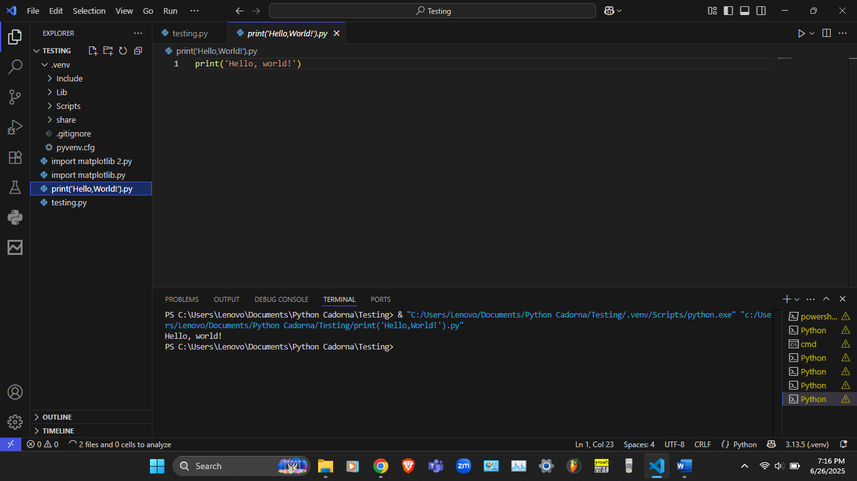
Figure 1: Print Hello, World!
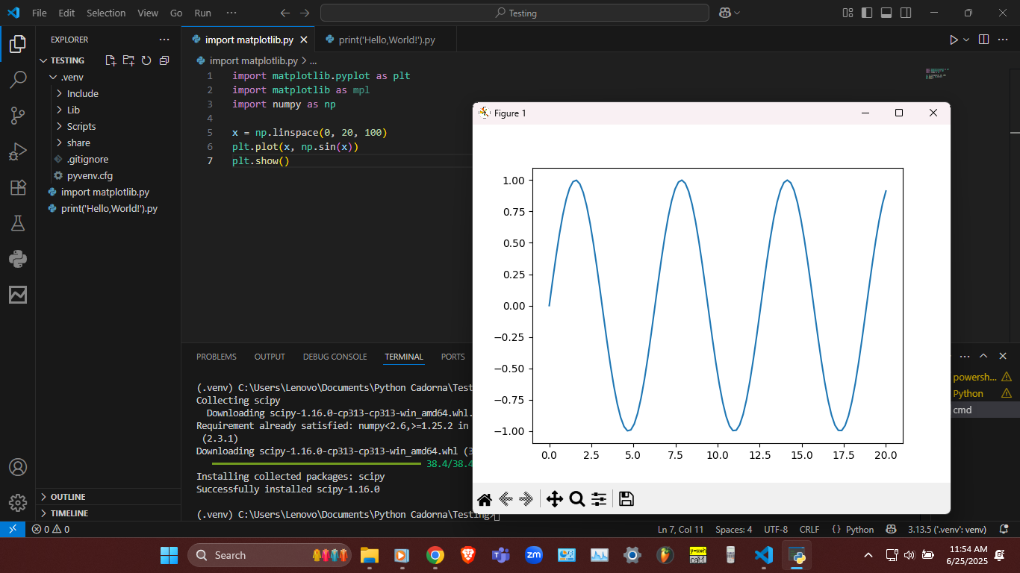
Figure 2: Plot
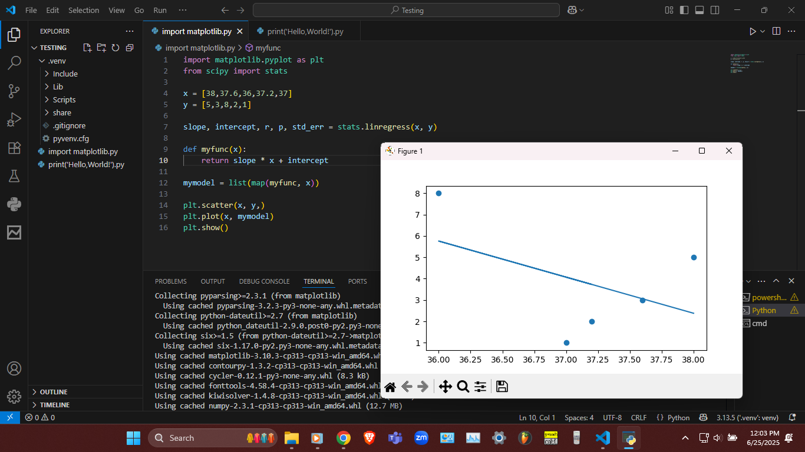
Figure 3: Linear Regression

